
BRAND GUIDELINES

INTRODUCTION
The following brand guidelines are designed to ensure that all authorized parties use THREAD GROUP’s brand elements consistently. We recommend that you refer to this guide whenever you develop marketing materials such as brochures, packaging, advertising, and digital communications.

LOGOTYPE

This is the primary logo to be used on all materials, excluding products and packaging. The loop and curves of the “T” represent the organic nature of THREAD. It is also a rotated “&” symbolizing connectivity.

LOGOTYPE

THREAD GRAY or KNOCKED-OUT WHITE are the approved colors for the LOGOTYPE.

MINIMUM SIZE CLEAR SPACE

0.75” (3/4”) Wide
2
X
2
X
2
X
2
X
X

LOGOMARK
THREAD GRAY or KNOCKED-OUT WHITE
are the approved colors for the LOGOMARK.
NOTE:
Never combine the LOGOTYPE & LOGOMARK.
MINIMUM SIZE | CLEAR SPACE

0.25” (1/4”) Wide
Logomark Height

LOGOTYPE & LOGOMARK APPLICATIONS
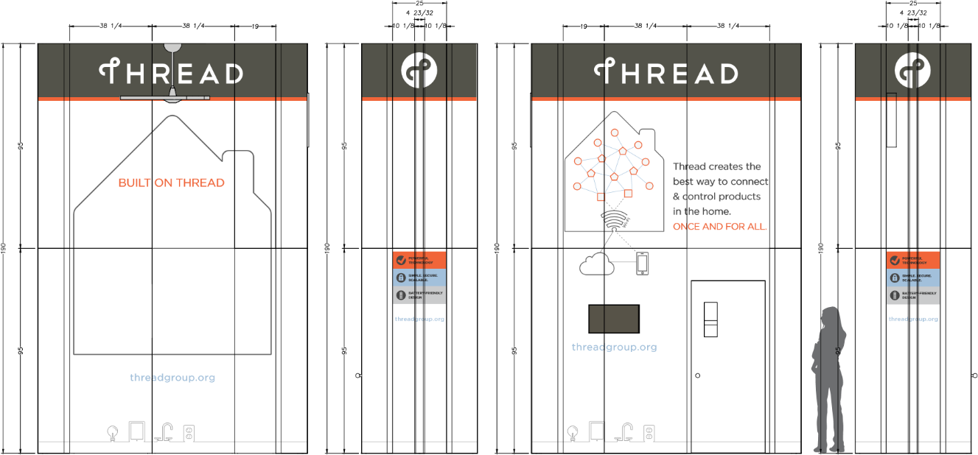
Above: Sample booth design

COLOR PALETTE PRIMARY

THREAD ORANGE
R 255 G 102 B 51
HEX #FF6633
C 0 M 75 Y 85 K 0
PMS Warm Red

THREAD GRAY THREAD MEDIUM GRAY
R 70 G 70 B 70 R 155 G 155 B 155
HEX #464646 HEX #9B9B9B
C 5 M 5 Y 5 K 85 C 0 M 0 Y 0 K 50
PMS Black 7 PMS Cool Gray 9

SECONDARY

DARK BLUE
R 150 G 170 B 190
HEX #96AABE
C 45 M 25 Y 15 K 0
PMS 7451
TERTIARY

MEDIUM BLUE

R 163 G 193 B 219

HEX #A2C1DB

C 35 M 15 Y 5 K 0

PMS 278

DARK GREEN
MEDIUM GREEN
R 190 G 225 B 210
HEX #BEE1D2
C 25 M 0 Y 20 K 0
PMS 331

R 160 G 205 B 185
HEX #A0CDB9
C 25 M 0 Y 20 K 0
PMS 345

LIGHT BLUE
R 217 G 226 B 237
HEX #D9E2ED
C 15 M 5 Y 0 K 0
PMS 656

LIGHT GRAY
R 247 G 247 B 247
HEX #F7F7F7
C 2 M 1 Y 1 K 0
PMS Cool Gray 1

LIGHT GREEN
R 230 G 245 B 240
HEX #E6F5F0
C 8 M 0 Y 6 K 0
PMS 5523

COLOR PALETTE EXAMPLES
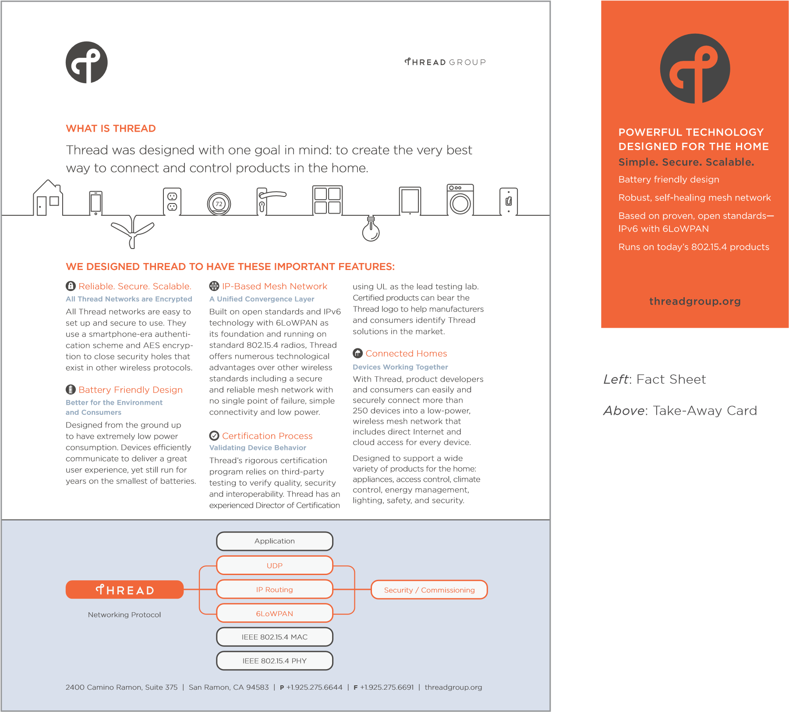

LOGOTYPE & LOGOMARK INCORRECT USE






Do not use gradients.

Do not create a pattern.

Do not use the logotype or logomark in non-approved colors.

Do not combine the logotype & logomark.

Do not crop the logomark.

TYPOGRAPHY
Montserrat is the primary typeface to be used for THREAD marketing materials and internal documents and can be downloaded from Google Fonts. The Arial family of typefaces may be used when Montserrat is not available. The preferred Montserrat and Arial fonts are shown below.

MONTSERRAT BOLD
ABCDEFGHIJKLMNOPQRSTUVWXYZ
abcdefghIjklmnopqrstuvwxyz
1234567890!@#$%&

MONTSERRAT MEDIUM
ABCDEFGHIJKLMNOPQRSTUVWXYZ
Abcdefghijklmnopqrstuvwxyz
1234567890@#$%&

MONTSERRAT REGULAR
ABCDEFGHIJKLMNOPQRSTUVWXYZ
abcdefghijklmnopqrstuvwxyz
1234567890@#$%&

MONTSERRAT LIGHT
ABCDEFGHIJKLMNOPQRSTUVWXYZ
abcdefghijklmnopqrstuvwxyz
1234567890@#$%&

ARIAL BOLD
ABCDEFGHIJKLMNOPQRSTUVWXYZ
abcdefghijklmnopqrstuvwxyz
1234567890!@#$%&

ARIAL REGULAR
ABCDEFGHIJKLMNOPQRSTUVWXYZ
abcdefghijklmnopqrstuvwxyz
1234567890@#$%&

THREAD GROUP LOGOTYPE

THREAD GRAY
or KNOCKED-OUT WHITE
are the approved colors
for the THREAD GROUP LOGO.

FOR NARROWER SPACES MINIMUM SIZE

0.75” (3/4”) Wide
This is the logo that represents the THREAD GROUP alliance. The horizontal version is preferred.
The vertical version is for placement in narrow spaces.

THREAD GROUP LOGOTYPE CLEAR SPACE
X
2
X
2
X
2
2
X
2
X
2
X
2
X
2
X

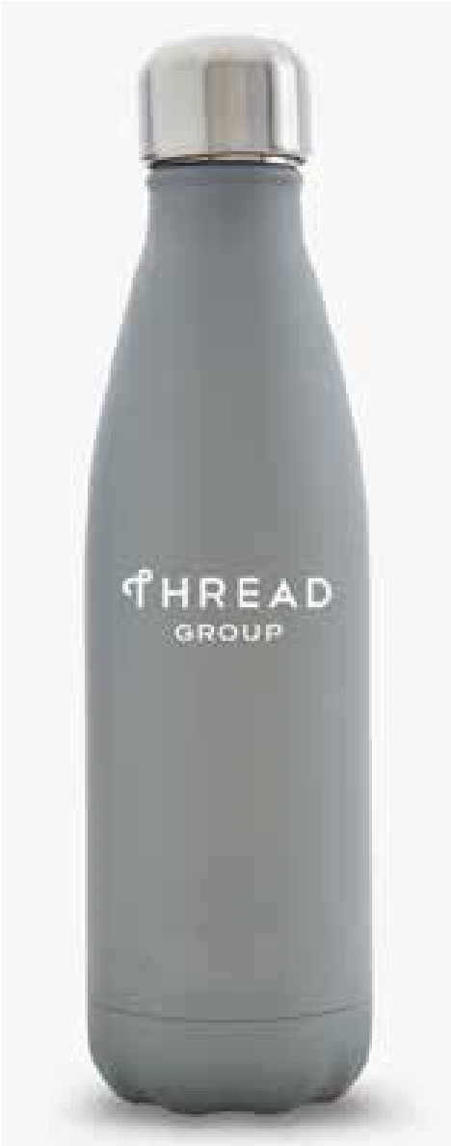
THREAD GROUP LOGOTYPE APPLICATIONS
(Thread Member Name)
(Title)

925.275.6644
name@email.com

threadgroup.org

5000 Executive Parkway, Suite 302 | San Ramon, CA 94583

Left: S’well Bottle
Above: THREAD GROUP Business Card

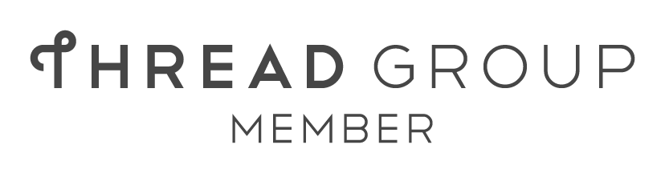
THREAD GROUP MEMBER LOGOTYPE


THREAD GRAY or
KNOCKED-OUT WHITE
are the approved colors for the THREAD GROUP MEMBER LOGO.
The THREAD GROUP Member logo may be used by alliance members in marketing collateral materials such as websites, brochures, etc.

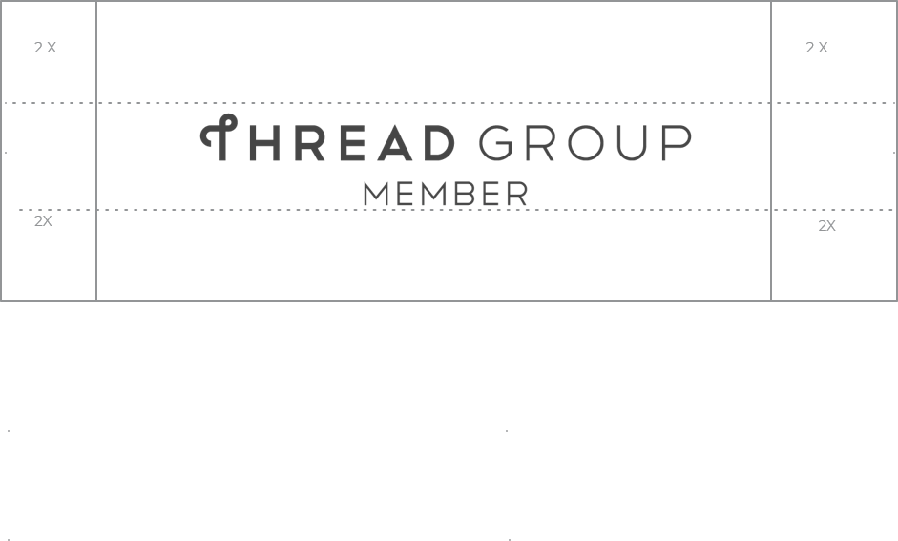
THREAD GROUP MEMBER LOGOTYPE CLEAR SPACE

THREAD CERTIFIED COMPONENT LOGO



FOR WIDER SPACES
MINIMUM SIZE
0.5”
(1/2”) Wide
1” Wide
The THREAD Certified Component logo may be used by alliance members who develop components such as software stacks, modules, etc. This logo may be used in horizontal and vertical formats in the above color combinations. Logos should not be translated or altered from the versions shown above.

THREAD CERTIFIED COMPONENT LOGO CLEAR SPACE
Logomark Height = X
X
X
X
X
Logomark Height = X
X
X
X
X

THREAD CERTIFIED COMPONENT LOGO APPLICATION
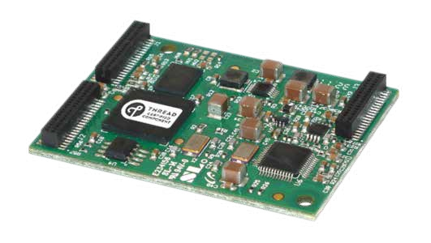
Above: Alliance Member’s Module

CONSUMER LOGOS -- BUILT ON THREAD

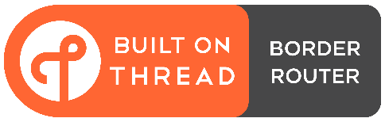
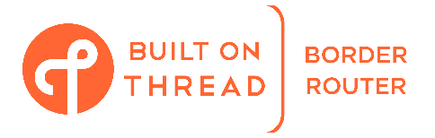
Built on THREAD Border Router
Preferred Version Above
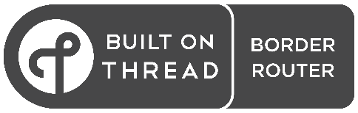
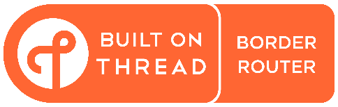

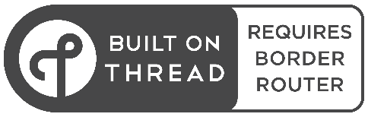
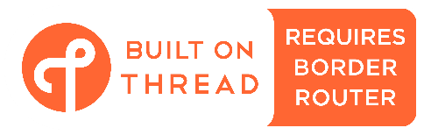
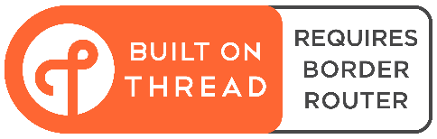
Built on THREAD Requires Border Router
Preferred Version Above
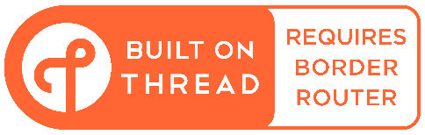

CONSUMER LOGO MINIMUM SIZE – BUILT ON THREAD BORDER ROUTER

MINIMUM SIZE

1” Wide
The “Built on THREAD” logos with “Border Router” and “Requires Border Router” badge options have been created to help educate and guide consumers on the need for a Border Router, and to help them identify products that include a Border Router. The use of these logos is optional but highly recommended for packaging and collateral materials for end user products that are consumer-facing and in particular, for Matter devices.

The logos are available in a horizontal format with “Border Router” and "Requires Border Router” variations in the above color combinations. Guidance is to use the two-color versions where possible. The single-color options are provided for cases where there is a dark background or if single-color printing is needed. Logos should not be translated or altered from the versions shown above.

CONSUMER LOGO CLEAR SPACE – BUILT ON THREAD
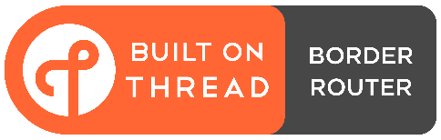
Logomark Height = X
X
X
X
X
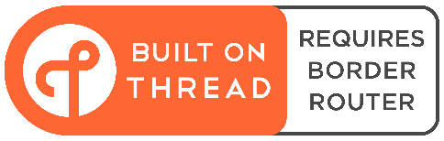
Logomark Height = X
X
X
X
X

CONSUMER LOGO APPLICATION – BUILT ON THREAD
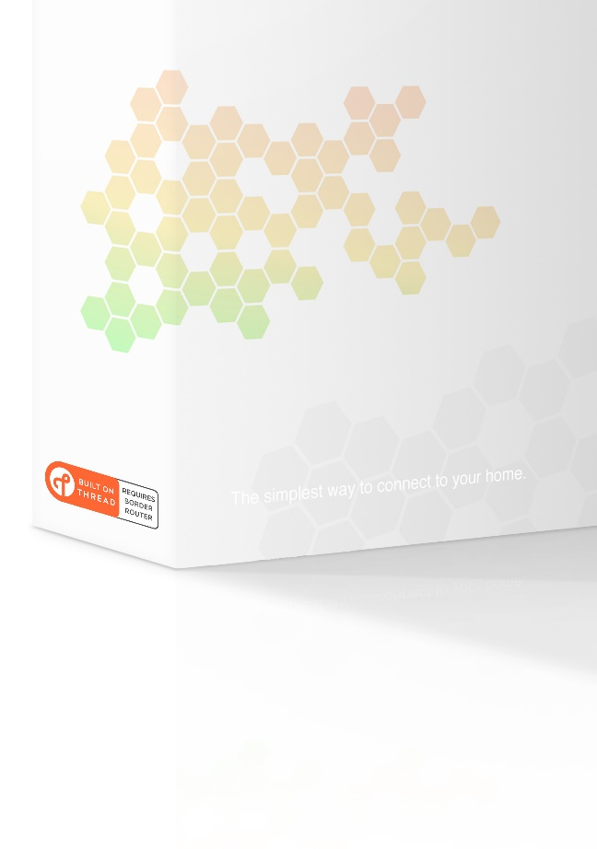
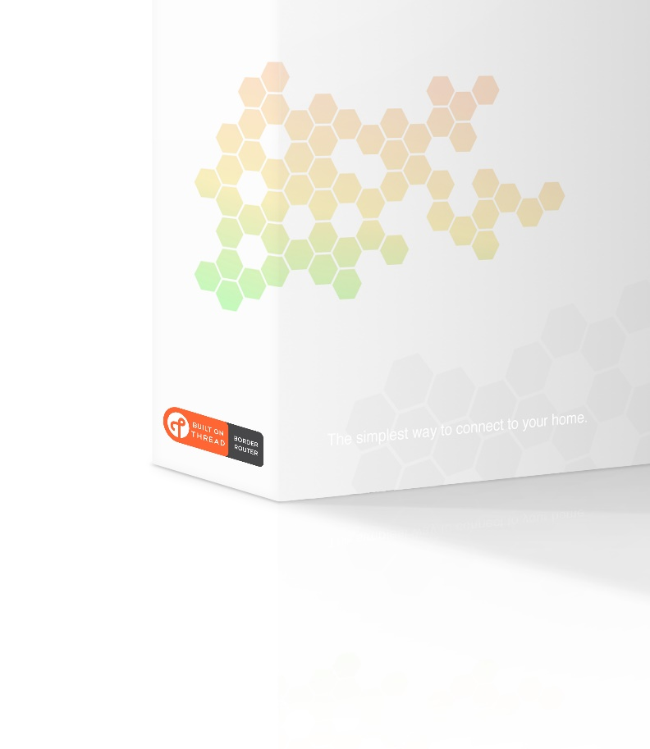
Above:
:
Consumer-facing Packaging

CONSUMER LOGO -- BUILT ON THREAD



FOR WIDER SPACES
MINIMUM SIZE
(1/2”) Wide
0.5”
1” Wide
A simplified version of the “Built on THREAD” consumer logo may be used on space-constrained packaging and collateral materials for end user products that are consumer-facing or for devices that are not consumer-facing. This logo may be used in horizontal and vertical formats in the above color combinations. Logos should not be translated or altered from the versions shown above. When referencing THREAD as a dual brand in text form for end user products, first indicate the primary brand and add “with THREAD” to denote inclusion. For example: DALI+ with THREAD.

CONSUMER LOGO CLEAR SPACE – BUILT ON THREAD
Logomark Height = X
X
X
X
X
Logomark Height = X
X
X
X
X

CONSUMER LOGO APPLICATION – BUILT ON THREAD

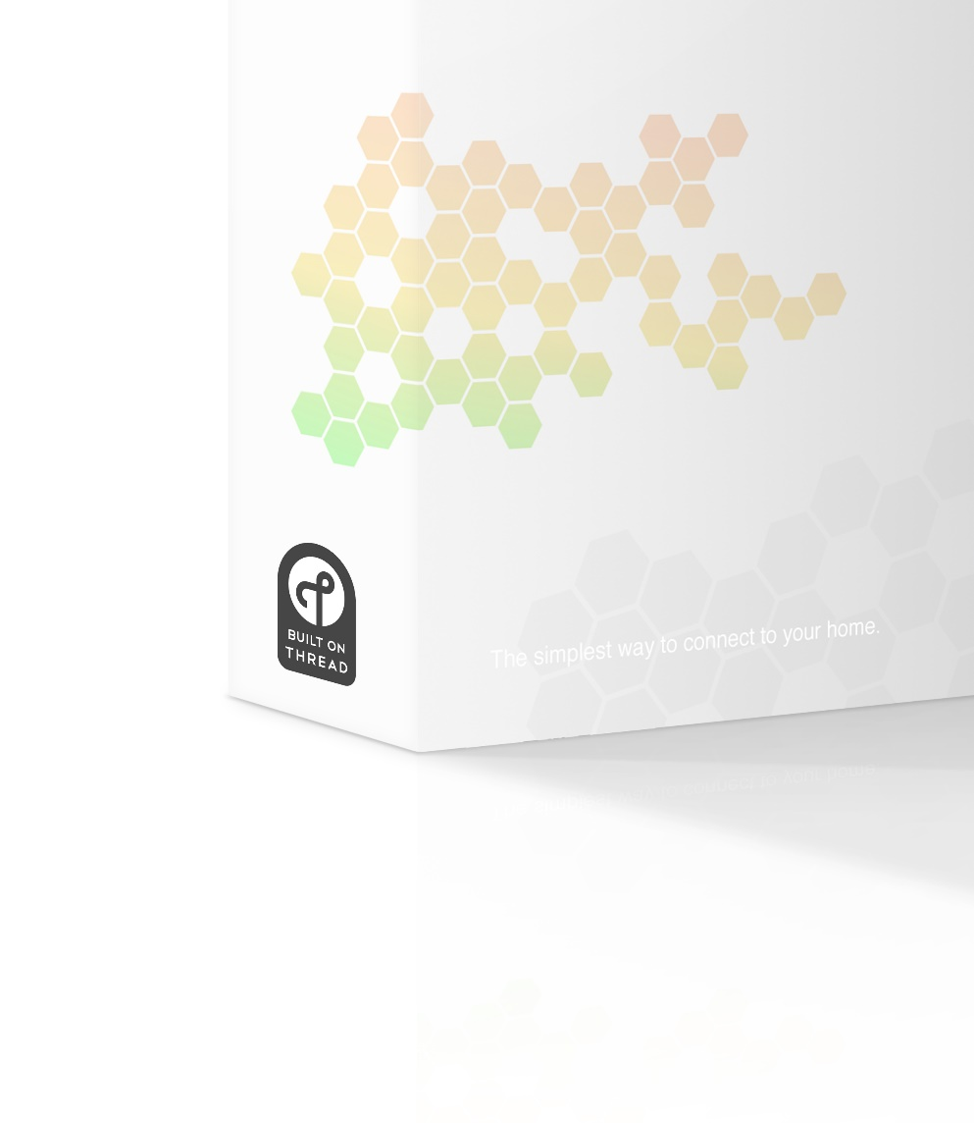
Above:
Consumer-facing Packaging

CONTINUOUS-LINE DRAWINGS

Products that are connected with THREAD should be illustrated as a continuous line drawing. They should be simple pictograms connected by line and spaced with visually equal distances between them.

THREAD STACK
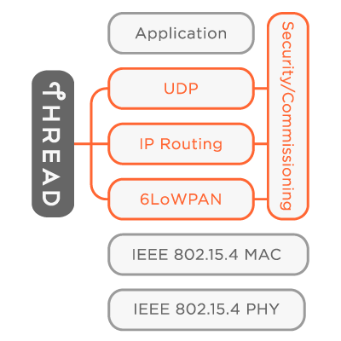

HOME

HOME NETWORK
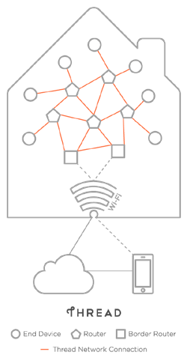

CONNECTED HOME

COMMERCIAL CITYSCAPE
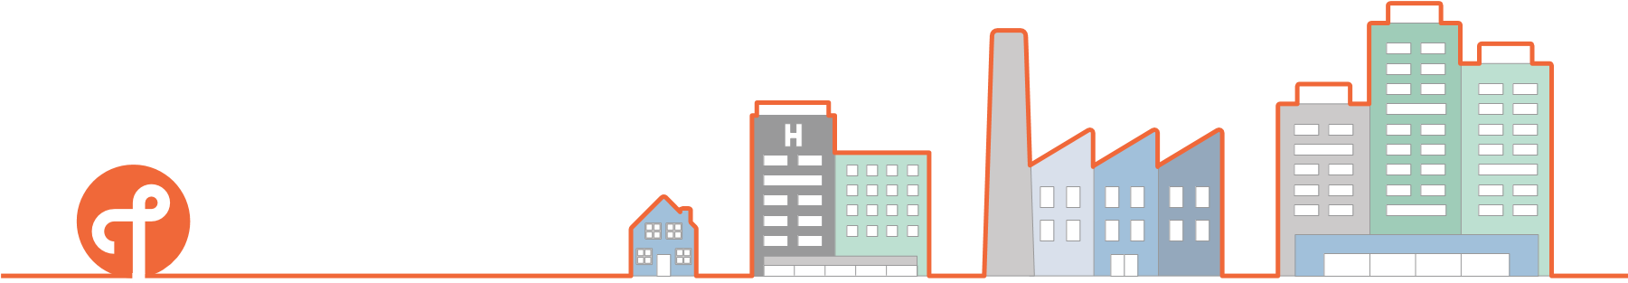

CERTIFICATION PROCESS

COMMERCIAL NETWORK
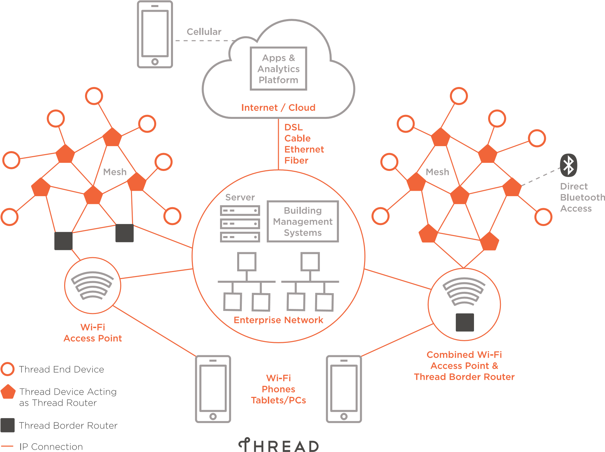

COMMERCIAL ICONS

CONSUMERS DEVELOPERS RETAILERS COMMERCIAL
 | Announcements  Available Now  Battery  Calendar  Certified  Challenge  Choose  Cloud  Committee  Compatible  Connected |  | Conversation  Email  Events  Forms  Gears  Global  Globe  Handshake  Home  Hot Topics  Idea |  | Info  IPv6  IPv6  Join  Locked / Secure  Logomark  Members  Network  News  Noteworthy  Papers (Apply / Downloads) |  | Play  Plus  Popular  Presentation  Press Kit  Questions  Quote  Ready  Reliable  Retail  Review |  | Scalable  Sent / Submit  Shopping Basket  Specs / Test  Star  Success  Talk Bubble  Time  Trophy  Unlocked  Video | View  Opening Quotes  End Quotes  Retailers  Retailers  Search  Developers  Consumers

