Bluetooth Wireless Technology FAQ - 2012
July 24, 2012
Abstract
This FAQ provides information about Bluetooth wireless technology support for the Windows family of operating systems. It is intended primarily for independent hardware vendors (IHVs) who are new to the Bluetooth ecosystem on Windows and addresses topics of interest to both hardware and software developers.
This information applies to the following operating systems:
Windows 8
Windows 7
Windows Vista
Windows XP
References and resources discussed here are listed at the end of this paper.
The current version of this paper is maintained on the Web at:
Bluetooth Wireless Technology FAQ - 2012

Disclaimer: This document is provided “as-is”. Information and views expressed in this document, including URL and other Internet website references, may change without notice. Some information relates to pre-released product which may be substantially modified before it’s commercially released. Microsoft makes no warranties, express or implied, with respect to the information provided here. You bear the risk of using it.
Some examples depicted herein are provided for illustration only and are fictitious. No real association or connection is intended or should be inferred.
This document does not provide you with any legal rights to any intellectual property in any Microsoft product. You may copy and use this document for your internal, reference purposes.
© 2012 Microsoft. All rights reserved.


Document History
Date | Change
July 24, 2012 | Updated information about Windows 8
January 15, 2010 | Updated for 2010
August 27, 2008 | Updated for 2008
September 17, 2007 | First publication

Contents
Introduction 3
General Operating System Support 4
Bluetooth Host Radio Support 10
User Interface 14
Windows Hardware Certification Program 17
Resources 19
Appendix A: How to Install an In-Box Bluetooth Driver on New Hardware in Windows Vista 20
Appendix B: An Example of a Vendor-Provided INF File for Use in Windows Vista 23

Introduction
This FAQ provides answers to a range of common questions about how Windows® supports Bluetooth wireless technology. For convenience, the following list provides links to the questions.
General Operating System Support
Which versions of Windows support Bluetooth wireless technology?
Which Bluetooth versions does Windows support?
What is new in Windows 8?
What is new in Windows 7?
What is new in Windows Vista?
Which Bluetooth profiles have in-box Windows support?
Which Bluetooth versions does Windows support?
How many Bluetooth radios can Windows support?
Do users have to re-pair their Bluetooth devices after they upgrade a system to Windows 7?
What programming interfaces are new for Windows 8?
What programming interfaces are new for Windows 7?
What programming interfaces were new for Windows Vista?
How can Bluetooth and Wi-Fi radios coexist effectively?
How do I enable AFH in Windows?
How do I enable remote wake in Windows?
Bluetooth Host Radio Support
Which Bluetooth host controllers does Windows support?
In Windows Vista, can the Bluetooth stack be forced to load if Windows cannot match the device ID?
How do I ensure in-box support for Bluetooth radios in Windows Vista?
Should third-party INF files use the Microsoft-defined class GUID?
Why is the Control Panel Bluetooth application missing in Windows 7?
Why does the Bluetooth icon not appear in the taskbar?
Does Windows support Bluetooth radio firmware updates?
Does Windows support vendor-specific pass-through commands?
Does Windows support vendor-supplied profiles?
Why are only some Bluetooth profiles and protocols enabled by default?
Can Group Policy block Bluetooth radio installation?
How do I change the Device ID Profile record published by Windows 8?
User Interface
What is the Bluetooth File Transfer Wizard?
How do I unhook Fsquirt.exe (enhancing the in-box Bluetooth File Transfer Wizard)?
In Windows Vista, why does the Bluetooth notification area icon sometimes disappear?
Can vendors add tabs to the Control Panel Bluetooth Settings application?
Why does Windows 7 and Windows Vista display a dialog box when a Bluetooth audio device is initially connected?
How do I enhance the functionality and better represent my Bluetooth device in Devices And Printers?
Windows Hardware Certification Program
Where are the Windows Hardware Certification Program requirements for Bluetooth wireless technology?
Does Windows 8 have new Bluetooth requirements?

General Operating System Support

Which versions of Windows support Bluetooth wireless technology?
The following versions of Windows include in-box support for Bluetooth wireless technology:
- All SKUs of Windows XP with SP2 and later versions
- All SKUs of Windows Vista
- All SKUs of Windows 7
- All SKUs of Windows 8

The following versions of Windows do not have in-box support for Bluetooth wireless technology:
- All SKUs of Windows 2000
- All SKUs of Windows Server 2003, Windows Server 2008, Windows Server 2008 R2, and Windows Server 2012

Although these versions of Windows do not have in-box Bluetooth wireless technology support, third-party Bluetooth drivers might be available from independent hardware vendors (IHVs).
Note: The Windows XP SP1 release supported Bluetooth wireless technology, but did so with a driver that was available only to PC system partners. Windows XP SP2 integrated Bluetooth wireless technology support into a regular service pack release and was available to all customers.

Which Bluetooth versions does Windows support?
Windows supports Bluetooth version 1.1 and later versions. Windows does not support Bluetooth version 1.0 because that specification lacks several critical updates that Windows requires to support Bluetooth wireless technology well. Windows Vista with SP2 and Windows 7 both support Bluetooth version 2.1. Note that Bluetooth version 2.1 radios and devices are backward compatible with earlier versions of Bluetooth and will run on Windows XP and Windows Vista without SP2. However, these Windows versions cannot take advantage of the full Bluetooth version 2.1 feature set because the Bluetooth version 2.1 specification was not ratified before Windows Vista was released.
Windows 8 is Bluetooth Smart Ready, it supports Bluetooth version 4.0, and is able to connect with Bluetooth Smart devices.
Windows support for different versions of the Bluetooth specification depends on the Windows version, as shown in Table 1.
Table 1. Windows Support for Bluetooth Versions
Windows version | Supported Bluetooth versions
Windows 2000 | Not supported.
Windows XP | Version 1.1  Version 2.0  Version 2.0 with enhanced data rate (EDR)
Windows Server 2003 | Not supported.
Windows Vista | Version 1.1  Version 2.0  Version 2.0 with EDR*  Version 2.1 with EDR**
Windows 7 | Version 1.1  Version 2.0  Version 2.0 with EDR*  Version 2.1 with EDR
Windows Server 2008 | Not supported.
Windows Server 2008 R2 | Not supported.
Windows 8 | Version 1.1  Version 2.0  Version 2.0 with EDR*  Version 2.1 with EDR  Version 4.0 with EDR
Windows Server 2012 | Not supported.
*The EDR support for Windows 8, Windows 7, and Windows Vista is enhanced relative to the Bluetooth stack for
Windows XP.
**Version 2.1+EDR is supported in Windows Vista with SP2.

What’s new in Windows 8?
Windows 8 includes the following enhancements to the Bluetooth stack and related software:
- Support for Bluetooth version 4.0:
Bluetooth Low Energy support allows Windows to connect with Bluetooth Smart peripherals.
eL2CAP enables enhanced re-transmission and flow control for profiles that require this functionality.
- An extensible transport model allowing support for Bluetooth radios on non-USB buses.
- Support for the HFP, A2DP, and AVRCP Profiles.

What is new in Windows 7?
Windows 7 includes the following enhancements to the Bluetooth stack and related software:
- Support for Bluetooth version 2.1:
Secure Simple Pairing allows Windows to determine the best pairing method to use between devices, rather than requiring users to make that determination.
Extended Inquiry Response enables sharing a device’s friendly name much earlier in the pairing process.
- An improved user experience that enhances management of Bluetooth devices.
- Improved installation of USB Bluetooth radios.
Any USB device with a USB\Class_E0&SubClass_01&Prot_01 hardware ID will install as a Generic Bluetooth Adapter.

What is new in Windows Vista?
Windows Vista includes the following enhancements to the Bluetooth stack and related software:
- Improved enhanced data rate (EDR) performance.
- Adaptive frequency hopping (AFH). This feature improves the coexistence of Bluetooth radios and 802.11 (Wi-Fi) network adapters, both of which operate in the 2.4-GHz frequency range.
- Synchronous connection-oriented (SCO) link support. This support is necessary for the headset and hands-free profiles.
- Kernel-mode device driver interface (DDI) support for Logical Link Control and Adaptation Protocol (L2CAP), Service Discovery Protocol (SDP), and SCO.
- New Bluetooth hardware IDs, which are listed in Table 2.
Table 2. New Bluetooth Hardware IDs for Windows Vista
Vendor identifier (VID) | Product identifier (PID) | Description
03F0 | 011D | Hewlett Packard integrated Bluetooth module
03F0 | 011D&Rev_0017 | Hewlett Packard nc4200
03F0 | 171D | Hewlett Packard integrated Bluetooth module
03F0 | D104 | BT450 Bluetooth wireless printer and PC adapter
044E | 300A | Sony Bluetooth USB adapter
044E | 300C | Sony Bluetooth USB adapter
049F | 0086 | Hewlett Packard integrated Bluetooth module
049F | 0086&Rev_1393 | Hewlett Packard nx7000
0930 | 0508 | Toshiba Bluetooth adapter
0930 | 0509 | Toshiba Bluetooth adapter
0A5C | 201E | IBM integrated Bluetooth IV
0A5C | 2110 | ThinkPad Bluetooth with EDR
0B05 | 1712 | Generic Bluetooth adapter
0DB0 | 6855&Rev_2000 | Message signaled interrupt (MSI) Bluetooth device
413C | 8120 | Dell wireless Bluetooth module
413C | 8126 | Dell Truemobile 355 Bluetooth + EDR

Which Bluetooth profiles have in-box Windows support?
Windows includes in-box support for the Bluetooth profiles that are listed in Table 3.
Table 3. Windows 7 and Windows Vista In-Box Bluetooth Profiles
Profile | Description
HID 1.0 | Human Interface Device
PANU | Personal Area Network User
SPP | Serial Port Profile
OPP | Object Push Profile
DUN | Dial-Up Networking
HCRP | Hard Copy Replacement Profile

Windows 8 includes additional and updated Bluetooth profiles as listed in Table 4.
Table 4. Windows 8 In-Box Bluetooth Profiles
Profile | Description
HID 1.1 | Human Interface Device
PANU | Personal Area Network User
SPP | Serial Port Profile
OPP | Object Push Profile
DUN | Dial-Up Networking
HCRP | Hard Copy Replacement Profile
HFP 1.5 | Hands-Free Profile
A2DP 1.2 | Advanced Audio Distribution Profile
AVRCP 1.3 | Audio/Video Remote Control Profile
HOGP | HID over GATT Profile

Because Windows 8, Windows 7, and Windows Vista provide both kernel-mode and user-mode programming interfaces for their Bluetooth stacks, hardware and software vendors can implement additional profiles in both kernel mode and user mode. We encourage vendors that create such profiles to test their software by using the appropriate Windows Hardware Certification Kit (HCK) test suites and have their software packages digitally signed.

Which Bluetooth versions does Windows support?
Windows 8 supports Bluetooth version 4.0.
Windows 7 and Windows Vista with SP2 both support Bluetooth version 2.1. Windows Vista RTM and Windows Vista with SP1 both support Bluetooth version 2.0 with EDR.
Note: Windows Vista with SP1 also supports Bluetooth version 2.1 if it includes a package that was made available only to system partners. Windows Vista SP2 integrated the Bluetooth version 2.1 support into the service pack release so that it is available to all customers.

How many Bluetooth radios can Windows support?
The Bluetooth stack in Windows supports only one Bluetooth radio. This radio must comply with the Bluetooth specification and the latest Windows Hardware Certification Program requirements.

Do users have to re-pair their Bluetooth devices after they upgrade a system to Windows 8?
If users upgrade from Windows Vista to Windows 8, they must perform a clean installation of Windows 8. In this situation, any Bluetooth software that the OEM provides must be re-installed and all devices must be re-paired. If users upgrade from Windows 7 to Windows 8, complex devices such as phones might require re-pairing so that third-party drivers will reload. However, a simpler device such as a keyboard or a mouse does not require re-pairing.
Therefore, pairing information is preserved if users upgrade from Windows 7 to Windows 8 for some devices, primarily Bluetooth keyboards and mouse devices. This ensures that customers are not required to use a wired keyboard and mouse to upgrade their Windows version. They can use their Bluetooth keyboard and mouse for the entire procedure.

What programming interfaces are new for Windows 8?
Windows 8 introduces new APIs for accessing Bluetooth Smart peripherals via Bluetooth Low Energy, creating a bus driver for non-USB Bluetooth controllers via an extensible transport model, and creating enhanced L2CAP channels. For more information about these APIs, see Bluetooth Devices Reference.

What programming interfaces were new for Windows 7?
Windows 7 introduced new Ex versions of previous APIs to provide enhanced functionality. For example, the BluetoothAuthenticateDeviceEx function lets out-of-band data be passed into the function call for the device that is being authenticated. Similarly, the BluetoothRegisterForAuthenticationEx function includes pin request and numeric comparison functionality. Also, the BluetoothSendAuthenticationResponseEx function is called when an authentication request to send the numeric comparison response is received. For more information about the new Ex versions of these APIs, see “Bluetooth Functions” on the MSDN® Web site.

What programming interfaces were new for Windows Vista?
Windows Vista introduced a kernel-mode DDI for Bluetooth wireless technology, which provides access to SCO, SDP, and L2CAP. The DDI is included with Windows Driver Kit (WDK) build 6000, which was released with Windows Vista, and all later builds of the WDK. We do not intend to make the kernel-mode DDI available on earlier versions of Windows. The WLK can be used to verify that kernel-mode Bluetooth drivers comply with standard driver development practices and use the DDI correctly.
Windows Vista with SP2 and Windows 7 also support the user-mode RFComm and Bluetooth APIs. For more information, see ”Bluetooth” on the MSDN Web site.
The WDK includes documentation for the new kernel-mode DDI. For more information about how to download the WDK, see ”How to Get the WDK” on the WHDC Web site. The WLK includes documentation for Driver Test Manager (DTM). For more information about how to download the WLK, see “Windows Logo Kit” on the WHDC Web site.

How can Bluetooth and Wi-Fi radios coexist effectively?
Both Bluetooth and Wi-Fi radios operate in the 2.4-GHz frequency range, so they could momentarily try to use the same frequency. The frequency hopping technique that Bluetooth wireless technology uses prevents such a conflict from causing a complete connectivity loss, but it could reduce the transfer rates for both radios.
Version 2.0 of the Bluetooth specification supports AFH. With AFH, a Bluetooth radio senses traffic from other types of radios, marks the busy channels as ”noisy,” and avoids those channels as it hops frequencies. Windows Vista improves AFH even further by treating the ”air” as a shareable spectrum. This feature lets wireless technologies such as Wi-Fi adapters report which channels they intend to use. When the Bluetooth stack becomes active, it is notified of the reported in-use channels and marks them as noisy.

How do I enable AFH in Windows?
Windows 8, Windows 7, and Windows Vista include a shared-spectrum model to support AFH for Bluetooth radios that are based on version 2.0 and later versions of the Bluetooth specification. However, this feature is disabled by default. For a system to support the shared spectrum model, the OEM must explicitly enable the feature and specify the width of the frequency band that should be blocked around an active Wi-Fi channel. To specify the width of the frequency band, create a value of type REG_DWORD that is named ChannelAvoidanceRange under the following registry key:
HKLM\System\CurrentControlSet\Services\BthServ\Parameters

The ChannelAvoidanceRange value enables or disables spectrum sharing and specifies the width of the blocked frequency band. To enable spectrum sharing, set ChannelAvoidanceRange to the full width of the frequency band that should be blocked around an active Wi-Fi channel. The units are in MHz and can range from 20 to 40 (0.02 to 0.04 GHz). OEMs must determine an appropriate bandwidth based on a selected set of radios, antenna characteristics, and radio manufacturer feedback.
A new ChannelAvoidanceRange value takes effect only after the system has been rebooted. Ideally, the OEM should set the ChannelAvoidanceRange value during the preinstallation process.
For the Windows shared-spectrum model to work effectively, Wi-Fi miniport drivers must report their channel usage to the networking connections manager. The networking stack then passes the channel-use information to the Bluetooth stack.

How do I enable remote wake in Windows?
Windows 8, Windows 7, and Windows Vista with SP2 provide software support that lets Bluetooth-enabled keyboards and mouse devices wake the computer from sleep (S3) or hibernate (S4) system power states. For such a wake to be successful, the Bluetooth module must be self-powered and must have enough power to wake the computer. Even if Windows enables wake from the S4 system power state, the computer will not wake if the Bluetooth module has no power when the computer is in S4.
To enable Remote Wake in software, verify that the Bluetooth module can support wake and set the following registry values:
- HKLM\System\CurrentControlSet\Services\Bthport\Parameters
\SystemRemoteWakeSupported : (DWORD) 1
- HKLM\System\CurrentControlSet\Enum\USB\<vid_pid>\<Bluetooth Radio ID>
\Device Parameters\RemoteWakeEnabled : (DWORD) 1
- HKLM\System\CurrentControlSet\Enum\USB\<vid_pid>\<Bluetooth Radio ID>
\Device Parameters\DeviceRemoteWakeSupported : (DWORD) 1

Note: If the Bluetooth radio’s property page in Device Manager has a Power Management tab, the radio can support wake. If no Power Management tab exists, the radio might support wake, but it is unlikely.

Bluetooth Host Radio Support

Which Bluetooth host controllers does Windows support?
With Windows, a Bluetooth radio can be packaged as an external dongle or embedded inside a computer but it must be connected to one of the computer’s USB ports. The Bluetooth stack that is included with Windows 7 and Windows Vista does not support Bluetooth radio connections over PCI, I2C, serial, Secure Digital I/O (SDIO), CompactFlash, or PC Card interfaces. In Windows 8, radios connected over alternate transports can be added via a third-party bus driver. Refer to the Extensible Transport sections of the Bluetooth Devices Reference for more information.

In Windows Vista, can the Bluetooth stack be forced to load if Windows cannot match the device ID?
A new Bluetooth radio might not match any of the device IDs in the Bluetooth INF (Bth.inf) that is included with Windows. This prevents Windows from loading a Bluetooth stack for the device. IHVs should ensure that their radio works with the native Bluetooth stack in one of the following ways:
- Create an INF for the radio that references Bth.inf. For an example of a vendor-specific INF file for a Bluetooth radio, see Appendix B.
- Store an extended compat ID OS descriptor in the device firmware that specifies an appropriate compatible and subcompatible ID. For information about extended compat ID OS descriptors, see ”Microsoft OS Descriptors” on the WHDC Web site.
- Force the Bluetooth stack to load.
.
The following procedure summarizes how to use Device Manager to force the Bluetooth stack to load for a new radio:
1. Run the Control Panel Device Manager application and identify the Bluetooth radio on the list of devices.
2. To run the Update Driver Software Wizard, right-click the Bluetooth radio item and select Update Driver Software.
3. Use the wizard to force the Bluetooth stack to install.

For a detailed description of this procedure, see Appendix A.

How do I ensure in-box support for Bluetooth radios in Windows Vista?
IHVs should take the following steps to ensure that their Bluetooth radios have in-box support on Windows:
- Ensure that the radio supports the extended compat ID OS feature descriptor. For details, see “Microsoft OS Descriptors” on the WHDC Web site.
- Obtain a Windows logo for the Bluetooth radio hardware and the associated INF file. For an example of a vendor-specific INF file for a Bluetooth radio, see Appendix B.
- Use the Windows Dev Center - Hardware Dashboard to make the INF file available through Windows Update.

It is no longer possible to add radios to the in-box Bth.inf file for Windows Vista.

Should third-party INF files use the Microsoft-defined class GUID?
IHVs should use the Microsoft-defined class globally unique identifier (GUID) ({e0cbf06c-cd8b-4647-bb8a-263b43f0f974}) for Bluetooth devices only in those INF files that reference the in-box Bluetooth INF file (Bth.inf). This means that the device uses the native Windows co-installer, services, and notification area icon. IHVs that implement their own Bluetooth stack must create a vendor-specific class GUID and use the WLK test tools to ensure that the stack complies with the unclassified logo program.

Why is the Control Panel Bluetooth application missing in Windows 7?
In Windows 7, the Control Panel Bluetooth application was incorporated into Devices and Printers. Thus, adjusting the Bluetooth radio settings, managing Bluetooth devices, and adding new Bluetooth devices can only be performed from within Devices and Printers.

Why does the Bluetooth icon not appear in the taskbar?
If the Bluetooth icon does not appear in the taskbar, it could be due to one or more of the following reasons:
- The Bluetooth radio is turned off.
- The Bluetooth radio is in emulation mode.
- In the Bluetooth Settings dialog, the Show the Bluetooth icon in the notification area check box is not selected.

Does Windows support Bluetooth radio firmware updates?
Currently, the Bluetooth stack that is included with Windows does not directly support firmware updates. However, for Bluetooth radios connected through a USB port, Windows does support firmware updates in compliance with the USB Device Firmware Update (DFU) specification. IHVs can create a user-mode utility that communicates with their Bluetooth radio over the DFU interface to perform the firmware update and restart the radio.

Does Windows support vendor-specific pass-through commands?
Windows 8, Windows 7, and Windows Vista with SP2 include support for vendor-specific pass-through commands. These kernel-mode interfaces are documented in the WDK.

Does Windows support vendor-supplied profiles?
Windows8, Windows 7, and Windows Vista support vendor-supplied Bluetooth profiles. However, Windows XP does not. The GUIDs for those profiles that have been standardized by the Bluetooth SIG are included in the in-box INF file (Bth.inf).
When users pair a Bluetooth device with a computer, the device’s profiles are compared to the profiles that are listed in Bth.inf. If the device profile does not match one of those profiles, users receive a dialog box that asks them to provide appropriate vendor software.
Vendors that want a vendor-specific profile must use their own GUID and reference it in a vendor-specific INF file. This INF file can use Include and Needs directives to reference the appropriate Bth.inf sections and directives. For an example of a vendor-specific INF file, see Appendix B.

Why are only some Bluetooth profiles and protocols enabled by default?
The Bluetooth stack that is included with Windows provides in-box support for only some Bluetooth profiles. Vendors must implement the required services to support any other Bluetooth profiles, much as they do for USB and PCI. Windows can use the Bluetooth profiles that are enabled by default—referred to as supported profiles—to generate physical device objects (PDOs). This allows default loading of the drivers that are required to enable the profile. You can identify the supported profiles in the registry by looking at the SupportedServices and UnsupportedServices values under the HKEY_LOCAL_MACHINE\System\CurrentControlSet\Services\Bthport \Parameters key.
Note: The Bthport key is added to the registry only after you install a Bluetooth device.
Table 5 lists the profiles in Bth.inf that Windows supports.
Table 5. Windows XP Bluetooth Profiles
Service ID | Description
{00001101-0000-1000-8000-00805f9b34fb} | SPP
{00001103-0000-1000-8000-00805f9b34fb} | DUN
{00001124-0000-1000-8000-00805f9b34fb} | HID
{00001126-0000-1000-8000-00805f9b34fb} | HCRP

Table 6 lists the unsupported Bluetooth profiles and protocols. Note that, in this context, “unsupported” means that Windows does not automatically generate a PDO or devnode or display the Add New Hardware Wizard. Therefore, some in-box profiles and protocols are handled as if they are unsupported. For example, SDP is an in-box protocol that has a Bluetooth service ID but does not require a PDO. The SDP protocol is therefore marked as unsupported in Bth.inf to prevent the creation of a PDO.
Table 6. Unsupported Bluetooth Profiles and Protocols
Service ID | In-box | Description
{0000110a-0000-1000-8000-00805f9b34fb} | No | Audio Source
{0000110c-0000-1000-8000-00805f9b34fb} | No | AV Remote Target
{00001001-0000-1000-8000-00805f9b34fb} | No | Browse Group Service
{00001111-0000-1000-8000-00805f9b34fb} | No | Fax Service
{0000111f-0000-1000-8000-00805f9b34fb} | No | Handsfree Audio Gateway
{00001112-0000-1000-8000-00805f9b34fb} | No | Headset Audio Gateway
{00001104-0000-1000-8000-00805f9b34fb} | No | Infrared Mobile Communication (IRMC) Sync Service
{00001107-0000-1000-8000-00805f9b34fb} | No | IRMC Sync Commands
{00001106-0000-1000-8000-00805f9b34fb} | Yes | Obex File Transfer
{00001105-0000-1000-8000-00805f9b34fb} | Yes | Object Push
{00001117-0000-1000-8000-00805f9b34fb} | No | PAN group ad hoc network (GN)
{00001116-0000-1000-8000-00805f9b34fb} | No | PAN network access point (NAP)
{00001115-0000-1000-8000-00805f9b34fb} | Yes | PAN U
{0000112e-0000-1000-8000-00805f9b34fb} | No | Phone book client equipment (PCE) service
{0000112f-0000-1000-8000-00805f9b34fb} | No | Phone book server equipment (PSE) service
{00001200-0000-1000-8000-00805f9b34fb} | Yes | PnP service
{00001002-0000-1000-8000-00805f9b34fb} | No | Public Browse Group Service
{00001000-0000-1000-8000-00805f9b34fb} | Yes | SDP
{0000112d-0000-1000-8000-00805f9b34fb} | No | Sim Access

If IHVs do not want Windows to automatically generate a PDO for their device, they can add the service GUID to the list of unsupported services. For examples, see Bth.inf.

Can Group Policy block Bluetooth radio installation?
For details on how to use Group Policy to block the installation of Bluetooth radios, see ”Step-by-Step Guide to Controlling Device Installation and Usage with Group Policy.”

How do I change the Device ID Profile record published by Windows 8?
The Device ID Profile defines an SDP record that can be used to provide identity information to remote devices. Previous and current Windows versions have used the Device ID record published on paired devices to provide device-specific Hardware IDs for generic Bluetooth services.
Beginning with Windows 8, Windows will also publish a local Device ID record to identify the Windows 8 device to remote Bluetooth devices. The default values can be adjusted by OEMs to better identify their specific Windows 8 device. These values are defined as in Table 7 under the HKLM\System\CCS\services\BTHPORT\Parameters registry key:
Table 7. Default Device ID record published by Windows 8
ValueName | Type | Description | Default Value
DIDVendorIDSource | DWORD | 0x01 = Bluetooth SIG namespace | 0x01
 |  | 0x02 = USB Forum namespace
DIDVendorID | DWORD | OEM specified VendorID | 0x06 – Microsoft Vendor ID
DIDProductID | DWORD | OEM specified ProductID | 0x01 – Microsoft Windows
DIDVersion | DWORD | OEM specified product version | 0x0800 – Windows 8

User Interface

What is the Bluetooth File Transfer Wizard?
The Bluetooth File Transfer Wizard enables users to transfer files between a computer and a Bluetooth device. For example, users can transfer files between a computer and a mobile phone or a personal digital assistant (PDA). The Bluetooth File Transfer Wizard can also transfer files between two computers that support Bluetooth.
Note: The default GUI that the Bluetooth File Transfer Wizard uses is implemented in the Fsquirt.exe file. This file can be unhooked from the underlying transfer wizard mechanism to enable replacement of the default Bluetooth File Transfer Wizard GUI. For more information, see the following question.

How do I unhook Fsquirt.exe?
Software developers that desire to replace the in-box Bluetooth File Transfer Wizard with a proprietary application can unhook Fsquirt.exe from the underlying transfer wizard mechanism by performing the following steps:
- Create a DWORD value that is named DisableFsquirt under the HKLM\System\CurrentControlSet\Services\Bthport\Parameters key in the registry.
- Set the value of DisableFsquirt to 0x1.
- Either reboot or run the following command in a command prompt window: fsquirt.exe -UnRegister

To re-enable Fsquirt.exe, perform the following steps:
- Delete the DisableFsquirt value from the registry.
- Reboot or run the following command in a command prompt window: fsquirt.exe –Register

In Windows Vista, why does the Bluetooth notification area icon sometimes disappear?
In Windows Vista RTM and Windows Vista with SP1, the Bluetooth notification area icon appears when the Bluetooth radio is connected to the computer. The icon is configured to stay active for up to 10 minutes, but after that period the icon disappears from the notification area.
If users want a persistent Bluetooth notification area icon, they can select the Show the Bluetooth icon in the notification area check box on the Options tab of the Control Panel Bluetooth Settings application.
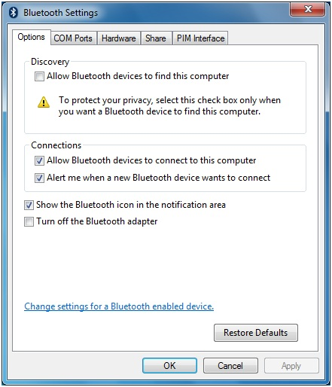
Figure 1. Control Panel Bluetooth Settings Application
Note: Even if no Bluetooth icon is in the notification area, you can still use the Control Panel Bluetooth Settings application to perform related tasks such as adding new Bluetooth devices, making the computer discoverable, and so on.

Can vendors add tabs to the Control Panel Bluetooth Settings application?
Yes, vendors can add tabs by implementing a shell property sheet handler for the application. For example, IHVs that implement extensions to the in-box Bluetooth stack can implement a property sheet handler that adds tabs for profiles such as file transfer, enhancements added to version 2.1 of the Bluetooth specification, and so on. For more information about how to implement property sheet handlers, see “Creating Property Sheet Handlers” on the MSDN Web site.

Why does Windows 7 and Windows Vista display a dialog box when a Bluetooth audio device is initially connected?
Windows might not provide default support for headset (HSP), hands-free (HFP), or advanced audio distribution (A2DP) audio profiles. If a Bluetooth audio device is paired with a system that does not have the necessary drivers, Windows typically displays the Found New Hardware dialog box. However, the dialog box does not appear if one of the following is true:
- The computer’s OEM provided a profile pack that supports Bluetooth audio.
- The end user previously installed a Bluetooth headset and downloaded the audio drivers from media that the IHV or Windows Update provided.

How do I enhance the functionality and better represent my Bluetooth device in Devices and Printers?
You can create a device metadata package for your Bluetooth device so that Devices and Printers displays device-specific information about your device, such as photorealistic icons and custom descriptions. This can significantly improve a user’s experience with your Bluetooth device. For example, you might want to more effectively expose all the features that your device supports. Certain device classes can also take advantage of Device Stage, which enables IHVs to further enhance the device experience by providing a customized and branded device-specific user interface.
For more information about how to create a device metadata package for your device, see “How to Create a Device Metadata Package for Devices and Printers” on the WHDC Web site.
For more information about Device Stage, see “Device Stage General Development Kit” on the MSDN Web site.
Note: To take advantage of Device Stage, the Device ID Profile must be implemented, which includes the Hardware ID, Vendor ID, and PID.

Windows Hardware Certification Program

Where are the Windows Hardware Certification Program requirements for Bluetooth wireless technology?
The Windows Hardware Certification Program specifies the requirements for hardware and software to work optimally with Windows. For specific details about the Windows Hardware Certification Program requirements for Bluetooth radios and devices, see Windows 8 Hardware Certification Requirements and Policies.
For general information about the Windows Hardware Certification Program, see Windows Hardware Certification.

Does Windows 8 have new Bluetooth requirements?
For Windows 8, the Windows Hardware Certification Program requires Bluetooth radios to support Bluetooth version 4.0 to qualify for a Windows logo. Updated tests are included in the latest version of the WLK. For more information about where to download the WLK, see Windows 8 Hardware Certification Requirements and Policies.

Resources

MSDN
Bluetooth
http://msdn.microsoft.com/en-us/library/aa362932(VS.85).aspx
Bluetooth Functions
http://msdn.microsoft.com/en-us/library/aa362927(VS.85).aspx
Bluetooth Device Driver Reference
http://msdn.microsoft.com/en-us/library/windows/hardware/ff536768(v=vs.85).aspx
Windows Hardware Certification Program
http://msdn.microsoft.com/en-us/windows/hardware/gg463010.aspx
Creating Property Sheet Handlers
http://msdn.microsoft.com/en-us/library/bb776850(VS.85).aspx
Windows 7 Device Stage General Development Kit
http://msdn.microsoft.com/en-us/library/ff547564.aspx
Installing Private Builds of In-box Drivers (Windows Vista and Later)
http://msdn.microsoft.com/en-us/library/ff547644.aspx
How to Create a Device Metadata Package for Devices and Printers
http://msdn.microsoft.com/en-us/windows/hardware/gg463145.aspx
How to Get the WDK
http://msdn.microsoft.com/en-US/windows/hardware/gg487428
Microsoft OS Descriptors
http://msdn.microsoft.com/en-us/windows/hardware/gg463179.aspx
Windows 7 Logo Kit
http://msdn.microsoft.com/en-us/windows/hardware/gg487530.aspx
Windows Logo Program Requirements and Policies
http://msdn.microsoft.com/en-us/windows/hardware/gg487403.aspx
Wireless Technologies
http://msdn.microsoft.com/en-us/windows/hardware/gg487357.aspx

Microsoft Download
Step-by-Step Guide to Controlling Device Installation and Usage with Group Policy
http://download.microsoft.com/download/3/b/a/3ba6d659-6e39-4cd7-b3a2-9c96482f5353/Step%20by%20Step%20Guide%20to%20Controlling%20Device%20Installation%20and%20Usage%20with%20Group%20Policy.doc

Organization
Bluetooth Special Interest Group
http://www.bluetooth.org

Appendix A: How to Install an In-Box Bluetooth Driver on New Hardware in Windows Vista
This appendix describes the procedure for forcing the Bluetooth driver that is included with Windows Vista to install on a new Bluetooth radio. Windows XP SP2 uses a similar procedure, although some of the details are different.

Step 1: Start Device Manager and Select the Bluetooth Radio
To start Device Manager:
1. Click Start, navigate to All Programs > Accessories > Command Prompt, right-click Command Prompt, and then click Run as administrator to open a command window with elevated privileges.
2. Type the following:
Devmgmt.msc

Under Other Devices, find the entry for the Bluetooth radio on the Device Manager list of devices. In Figure A-1, the radio’s name is ”UGT”. On some portable computers, you might be required to first turn on the Bluetooth radio by using a key combination such as Fn+F5.
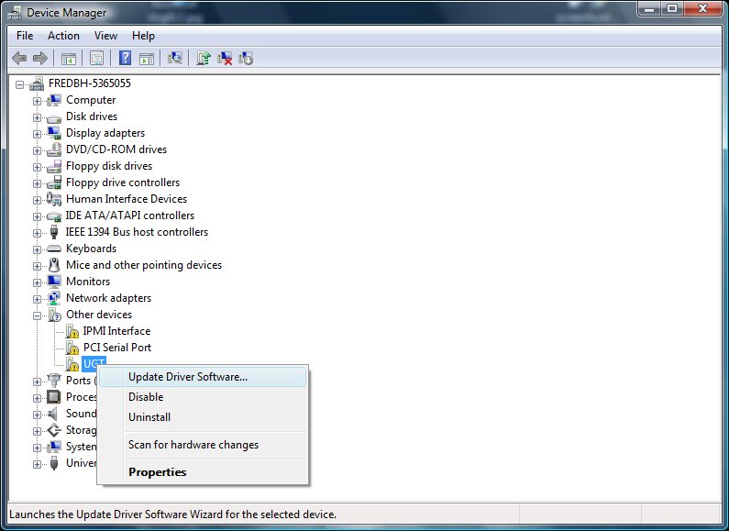
Figure A-1. Device Manager
To verify that the selected device is a Bluetooth radio, right-click the device name and then click Properties to display the Properties dialog box. On the Details tab, verify that the device has the compatible ID for a Bluetooth radio:
USB\Class_e0&SubClass_01&Prot_01

Step 2: Start the Update Driver Software Wizard
Right-click the Bluetooth radio node and then click Update Driver Software. To go to the page in Figure A-2, click Browse my computer for driver software. To manually select a driver, click Let me pick from a list of device drivers on my computer.
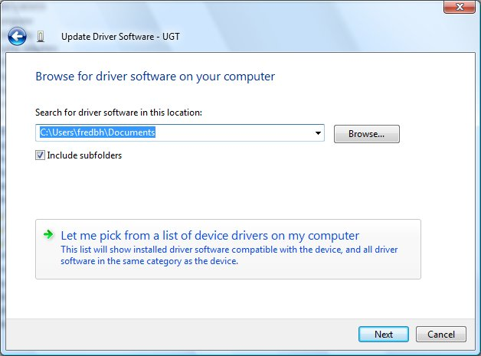
Figure A-2. Update Driver Software Wizard: Manually Install a Driver

Step 3: Select the Generic Bluetooth Driver
The Update Driver Software Wizard next displays a list of available drivers. Select Bluetooth Radios and then select a Bluetooth radio that matches your system, as shown in Figure A-3. If you are not sure which driver to use, you can use the generic driver for testing. To do this, select Generic Adapter as manufacturer and Generic Bluetooth Adapter as the model.
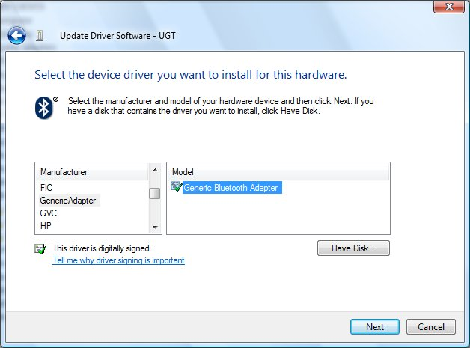
Figure A-3. Update Driver Software Wizard: Select Generic Bluetooth Driver
After you select a driver, the wizard asks you to confirm that you want to install the specified driver on the new Bluetooth radio. If you try to install a Bluetooth driver on a device that is not a Bluetooth radio, the driver will probably not start.
If the driver loads correctly, Device Manager should have a Generic Bluetooth Adapter entry under the Bluetooth Radios node, as shown in Figure A-4.
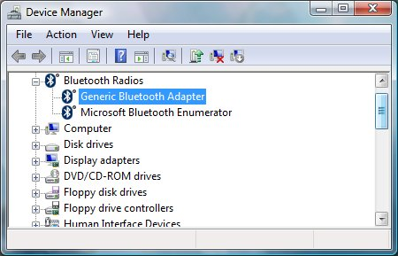
Figure A-4. Device Manager: The Newly Installed Driver
If the driver failed to start, for example, if Windows returned a start error code, examine the event log to help determine the cause.

Appendix B: An Example of a Vendor-Provided INF File for Use in Windows Vista
This appendix includes an example of how to implement a vendor-provided INF file that references Bth.inf. This particular example is implemented to install a radio that is compatible with version 2.0 plus EDR of the Bluetooth specification in Windows XP or Windows Vista. The INF files for other types of Bluetooth devices are similar. This INF file can be used to install the device on the following versions of Windows:
- All SKUs of the 32-bit version of Windows XP SP2 and later service packs.
- All SKUs of the 64-bit version of Windows XP.
- All SKUs of Windows Vista.

Note: This INF file cannot be used with Windows 2000, Windows Server 2003, or any versions of Windows XP that have not been upgraded to at least SP2. Also, a vendor-provided INF file is not necessary for Windows 7 because any USB device that has a USB\Class_E0&SubClass_01&Prot_01 hardware ID will install as a Generic Bluetooth Adapter in Windows 7.
For an explanation of the highlighted sections and directives, see the numbered notes after the following sample:
; XYZ Vendor INF File for Bluetooth Radio
;
; A sample INF for a stand-alone Bluetooth radio that does not
; have native Windows Vista support

; [1]
[Version]
Signature = "$Windows NT$"
Provider = %ProviderName%
Class = Bluetooth
CLASSGUID = {e0cbf06c-cd8b-4647-bb8a-263b43f0f974};
DriverVer = 10/28/2006,6.0.0.0 ;
CatalogFile.NT = BTHXYZ1.CAB

[ControlFlags]
ExcludeFromSelect=*

[SourceDisksNames]
1=%SourceDisk%,,1

[Manufacturer]
%ManufacturerName% = XYZBth,NT.5.1,NTx86,NTamd64

; Match on a hardware ID generated by the device, for x86 and x64.

; [2]
[ZYXBth.NT.5.1]
%BthRadio1% = Bt1.NT.5.1, USB\VID_xxxx&PID_yyyy
[ZYXBth.NTx86]
% BthRadio1% = Bt1.NT.5.1, USB\VID_xxxx&PID_yyyy
[ZYXBth.NTamd64]
% BthRadio1% = Bt1.NT.5.1, USB\VID_xxxx&PID_yyyy

; Windows XP specific sections -------------------------

; [3]
[Bt1.NT.5.1]
include = bth.inf
needs = BthUsb.NT

[Bt1.NT.5.1.HW]
include = bth.inf
needs = BthUsb.NT.HW
DelReg = DeleteRegKeys

[Bt1.NT.5.1.Services]
include = bth.inf
needs = BthUsb.NT.Services

; [4]
[DeleteRegKeys]
; Delete support for the Microsoft FaxService
HKLM,"SYSTEM\CurrentControlSet\Services\Bthport\Parameters\UnsupportedServices","{00001111-0000-1000-8000-00805f9b34fb}"

[Strings]
; While strings are localizable, in this sample INF, we have
; not created any localized strings.
ProviderName = "Vendor XYZ (c)"
ManufacturerName = "Vendor XYZ (c)"
BthRadio1 = "Bluetooth 2.0+EDR Model 3.2 from XYZ (c)"
SourceDisk = "Windows Vista CD"

Notes:
1. The Version section should have the CLASSGUID and DriverVer directives set as follows:
CLASSGUID. Use the Microsoft class GUID for Bluetooth devices ({e0cbf06c-cd8b-4647-bb8a-263b43f0f974}), not a third-party GUID.
DriverVer: If you want to supersede the default in-box driver, the driver version must be set to provide a higher ranking match than what is in Bth.inf. For more information about configuring a driver to supersede the default in-box driver, see “Installing Private Builds of In-Box Drivers (Windows Vista and Later)” on the MSDN Web site.
2. Hardware IDs. The combination of the VID and the PID must be unique to the manufacturer and device. This ensures that the same hardware ID does not correspond to multiple devices.
3. Include and Needs directives. The Include directives in these three sections reference Bth.inf. The Needs directives indicate which sections from Bth.inf should be processed during device installation.
4. The DelReg directive, which references the DeleteRegKeys section, deletes registry keys or values that prevent Windows from creating a PDO or devnode for a device. For example, the fax service profile is currently on the Windows Vista list of unsupported services, so it is a value of the UnsupportedServices registry key. This example deletes the fax services profile from the UnsupportedServices key, which lets Windows create a devnode for the device.
We strongly recommend that you run the latest WHQL tests on the device and INF file and publish the INF file package on Windows Update. This ensures that customers can automatically download the INF file from the Internet when they connect their new Bluetooth radio to their computer.

